Task 1: Linear Regression
A researcher wants to predict the life expectancy of countries based on socio-economic and health factors. You are tasked with building a Linear Regression model that can predict life expectancy using historical data.

CODE:

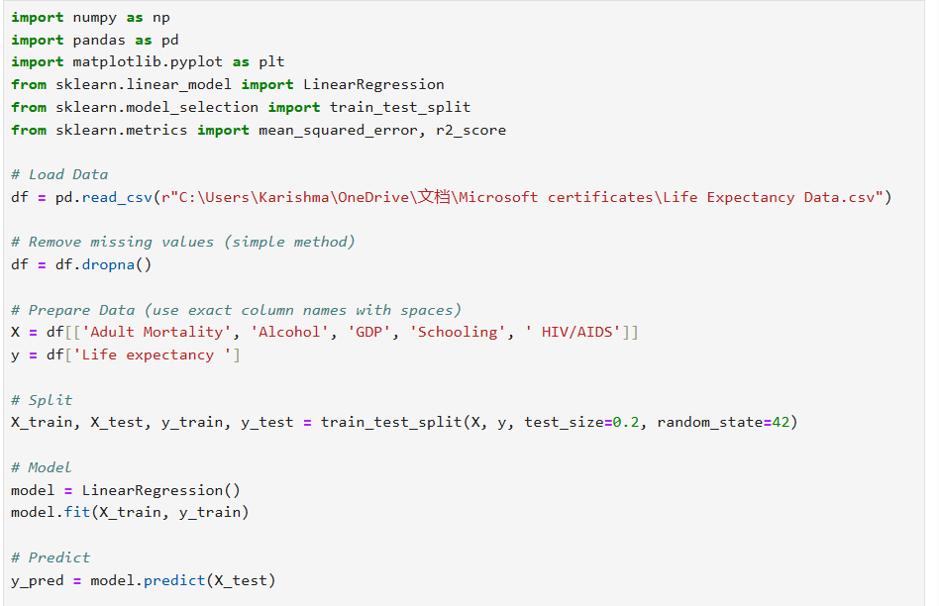
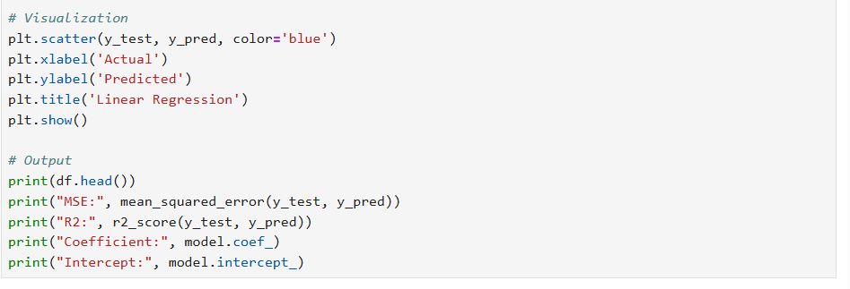

OUTPUT:

